**Exercise Class “Introduction into Cyber Security”**

Winter Term 2018/2019



**Chair of IT Security**

Topic:

Introduction into Cyber Security

– Buffer Overﬂow Attacks –

Deadline: 9th January, 2019

|  |  |
| --- | --- |
| **Supervised By:**  Torsten Ziemann | **Group: 14**  **Members:**  Siddique Reza Khan  [Sam Abubakar Tareque](https://www.b-tu.de/elearning/btu/user/view.php?id=15539&course=3890)  [Fathima Shaik](https://www.b-tu.de/elearning/btu/user/view.php?id=15151&course=3890) |

**1.0 Description of our Task:**

First, the task we have completed till now to find the exact length of the buffer and then overwrite the “get_time function” call return address with the msgbuf, global variable, address.

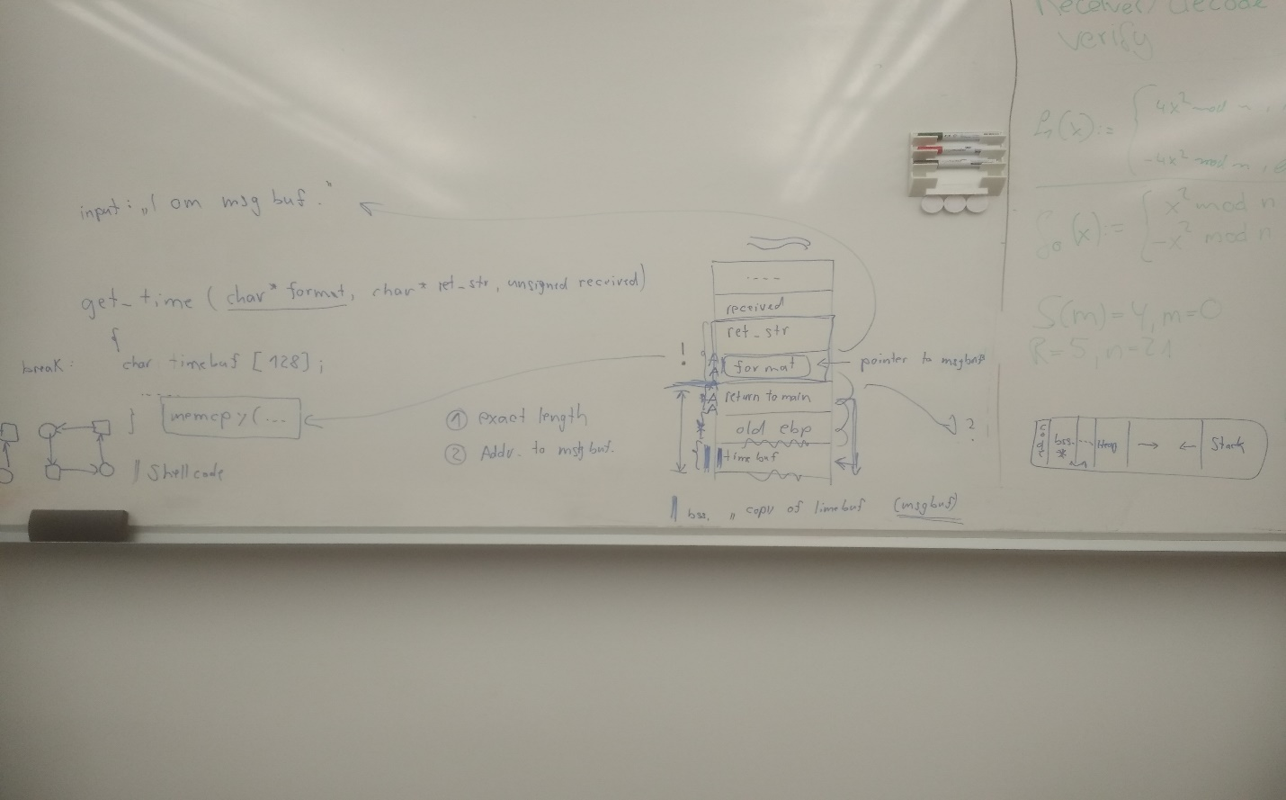

As we discussed had with you, it can be possible for us to print a message after redirect the return address pointing to the msgbuf, a global variable.

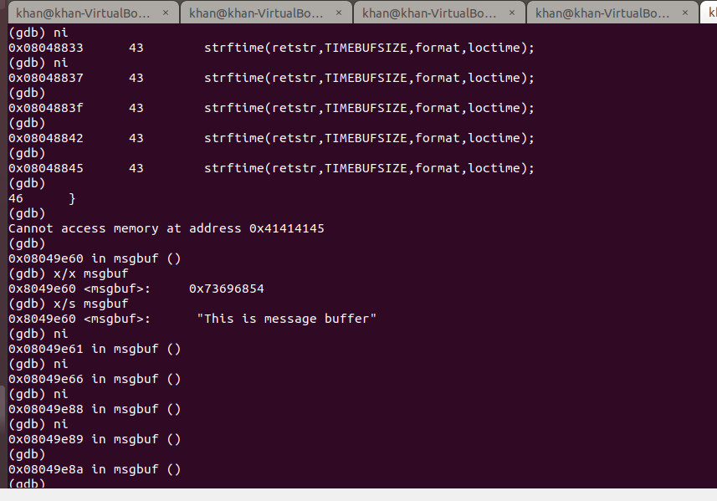

However we could manage to get the shell program named “/bin/bash” in the msgbuf memory address but after continue running it was hanging for sometimes.

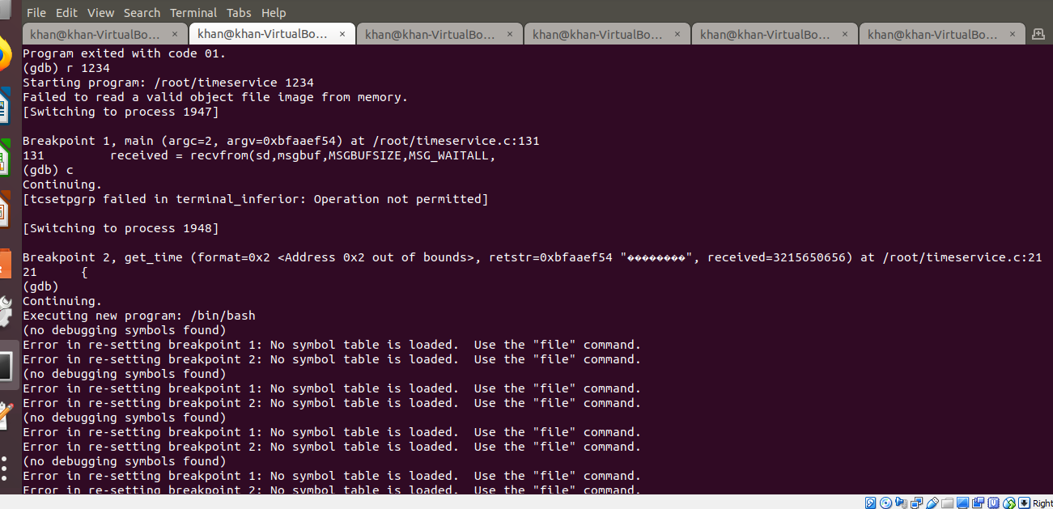

Last, we could get the shell. Whereas the “shell program” was not executed in our local attacker machine but we had a program crash with unusual termination.

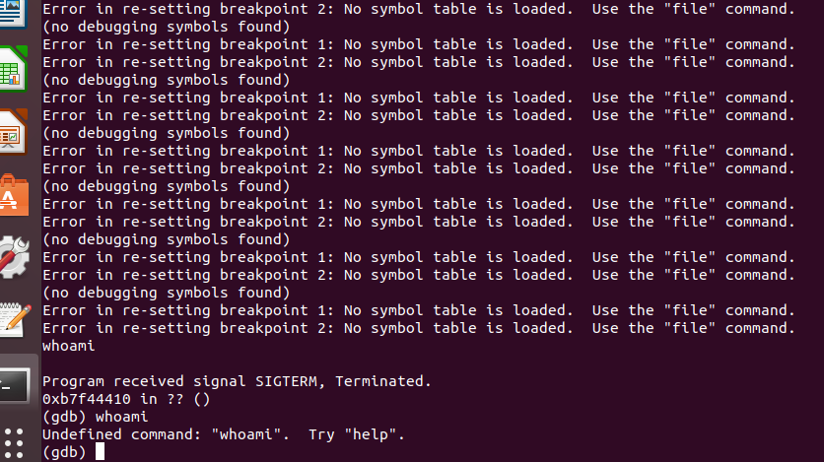

**2.0 Problem:**

As we discussed had with you in the lab, that we have to change our shell code with bind a port.

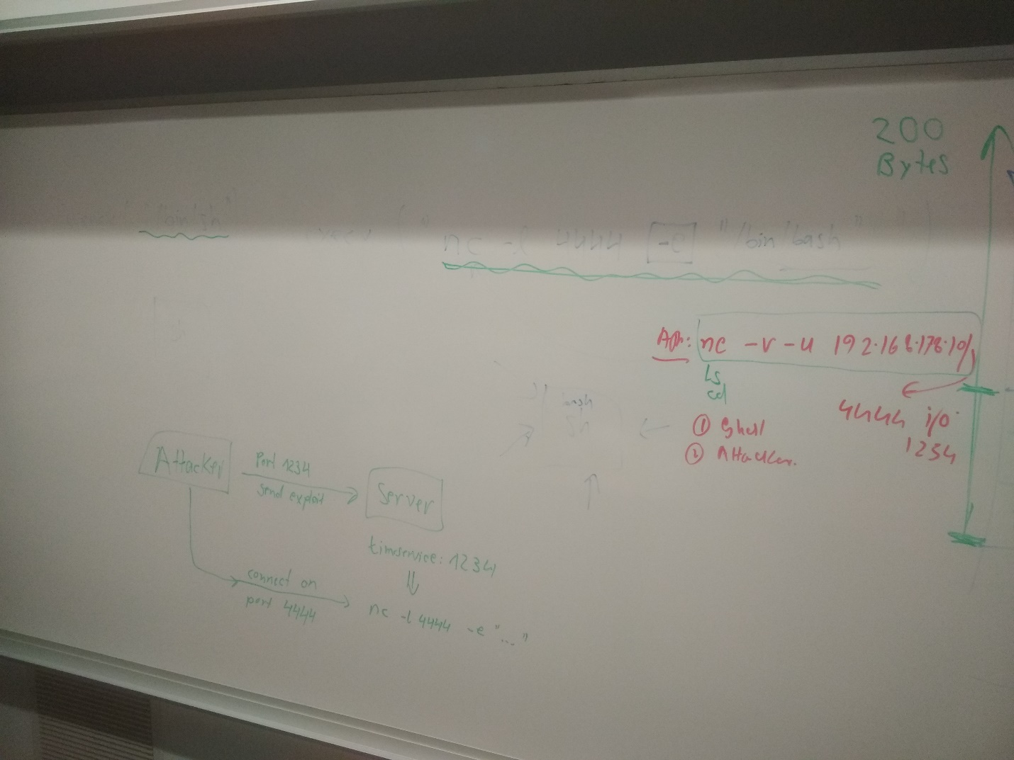

**3.0 Future Work:**

Our future goal to 1. Improve and generate the “shell code” as you suggested to us, 2. Exploit the local attacker machine 3. Run the shell into the server machine and 4. try to get the secret message from the server.

**4.0 Special Thanks:**

We are very much glad to get a wonderful guidance, support and cooperation from our supervisor, Mr. Torsten Ziemann.

**Bibliography:**

1. https://dhavalkapil.com/blogs/Buffer-Overflow-Exploit/
2. https://dhavalkapil.com/blogs/Shellcode-Injection/
3. https://dhavalkapil.com/assets/files/Shellcode-Injection/shellcode.asm
4. https://www.linuxnix.com/suid-set-suid-linuxunix/
5. http://www.primalsecurity.net/0x0-exploit-tutorial-buffer-overflow-vanilla-eip-overwrite-2/
6. https://sploitfun.wordpress.com/2015/05/08/classic-stack-based-buffer-overflow/
7. https://sploitfun.wordpress.com/author/sploitfun/
8. https://penturalabs.wordpress.com/2011/03/31/vulnerability-development-buffer-overflows-how-to-bypass-full-aslr/
9. https://www.slideshare.net/AlexandreMoneger/07-aslr-bypass
10. https://security.stackexchange.com/questions/157478/why-jmp-esp-instead-of-directly-jumping-into-the-stack
11. http://www.sheepshellcode.com/blog/2015/03/24/writing-buffer-overflow-exploits-with-aslr/
12. https://sploitfun.wordpress.com/2015/05/08/bypassing-aslr-part-i/
13. https://stackoverflow.com/questions/16110591/aslr-brute-force
14. https://hk.saowen.com/a/97794707e756f8e5724f107ea3f7d2ef7a388a157a8fb20080fee56f7b1ac646
15. https://cybersecurity.upv.es/attacks/offset2lib/offset2lib.html
16. https://security.stackexchange.com/questions/20497/stack-overflows-defeating-canaries-aslr-dep-nx
17. https://security.stackexchange.com/questions/18556/how-do-aslr-and-dep-work
18. https://dkalemis.wordpress.com/2010/10/27/the-need-for-a-pop-pop-ret-instruction-sequence/
19. https://www.corelan.be/index.php/2009/07/23/writing-buffer-overflow-exploits-a-quick-and-basic-tutorial-part-2/
20. https://www.corelan.be/index.php/2010/06/16/exploit-writing-tutorial-part-10-chaining-dep-with-rop-the-rubikstm-cube/
21. https://www.securitysift.com/windows-exploit-development-part-6-seh-exploits/